CS3714 iOS Mobile Software Development

Semester Project Report

Spring 2018

**Cufflink**

Joe K. Chu, [jchu247@vt.edu](mailto:jchu247@vt.edu)

Zuri Wong, [zuriw@vt.edu](mailto:zuriw@vt.edu)  
Christian J. Howe, [cjhowe@vt.edu](mailto:cjhowe@vt.edu)

Department of Computer Science

Virginia Tech

Blacksburg, VA 24061

*Date:* May 2, 2018

*Team Number:* 14

*Instructor:* Prof. Osman Balci

**EXECUTIVE SUMMARY**

Cufflink is a multiuser social platform for users to easily borrow and rent out business professional clothings. User can post or view available items in Home Table View with simple user friendly design.

**List of Implemented iOS Features Learned** (At least 3 required per team member)

1. Create an image slideshow
2. Create Global Data and use it in any class in your project
3. Scroll up the entire UI content to show a Text Field hidden under the keyboard
4. Custom-built Table View of potential borrowers
5. Read from a server computer over the network
6. Ask for user's permission to access the iOS device's camera
7. Using the Unwind design pattern
8. Determine and show user's current Location
9. Forward Geocoding
10. Ask for user's permission to track geo-location
11. Remove keyboard by touching anywhere on the view's background
12. Using the Delegation design pattern

**List of Implemented New iOS Features (**At least 1 required per team member)

1. Select photos from user’s phone Photo Library
2. Opens Messaging app and pulls phone number
3. Use activity indicator to load scenes

This page must be numbered as ii. No page number must appear on the title page.

**TABLE OF CONTENTS**

Executive Summary

1. SOFTWARE LIFE CYCLE 1

2. OUR OBJECTIVE 2

3. PROBLEM SPECIFICATION 2

3.1 What is the problem? 2

3.2 Why is the problem important to solve by engineering an iOS application? 2

3.3 Learned and new iOS features to be implemented 2

4. REQUIREMENTS SPECIFICATION 4

4.1 Functional Requirements 4

4.2 Non-Functional Requirements 4

5. ARCHITECTURE SPECIFICATION 5

6. DESIGN SPECIFICATION 13

7. DELIVERED SOFTWARE FUNCTIONALITY 14

8. STEP-BY-STEP INSTRUCTIONS FOR DEVELOPING NEW FEATURES 26

8.1 Use Activity Indicator to load scenes 26

8.2 Select Photos from User’s Phone Photo Library 27

8.3 Opens Messaging app and pulls phone number 32

9. CONCLUSIONS 34

10. SUBMISSION INSTRUCTIONS 34

11. PERCENTAGES OF CONTRIBUTION 34

12. CALCULATION OF GRADES BASED ON PERCENTAGES OF CONTRIBUTION 36

13. TEAM PROJECT REQUIREMENTS 36

14. GRADING SHEET 37

# SOFTWARE LIFE CYCLE

A good software engineer develops software by following the software life cycle shown below.

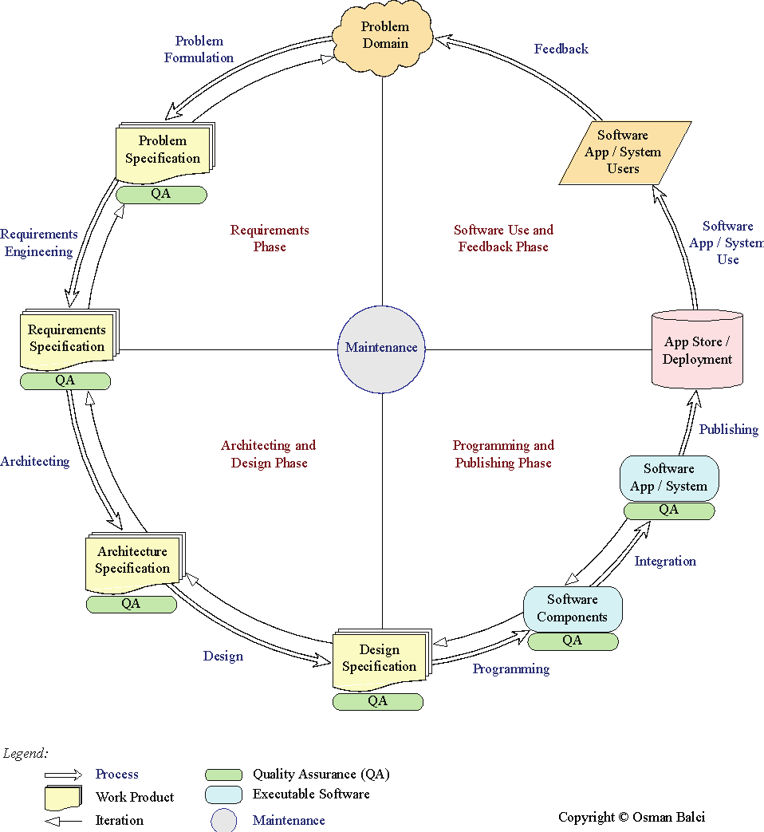

A programmer (hacker or ad-hoc developer) develops software by looking at the problem and directly coding in an IDE. This approach is known as the *Build-and-Fix Approach*, which must never be used!

# OUR OBJECTIVE

The objective of our iOS team project is to **demonstrate how capable the team members are** in engineering an iOS app to solve a problem. The app is created for the purpose of showing how *learned* and *new* complex functionalities and iOS features the team members are capable of developing. The objective is **not** to develop an app for publishing it at the App store.

# PROBLEM SPECIFICATION

## What is the problem?

Many people do not have enough money to afford expensive formal attire. This is a large problem when it comes to student life with students not being able to look professional enough for their upcoming interviews due to a lack of formal dress wear. With our app Cufflink, users will be able to rent out their formal attire to other users, allowing user to be able to use professional attire for their important interviews and events, without having to spend the full price for formal attire.

## Why is the problem important to solve by engineering an iOS application?

In today society, smartphones are very prevalent in a person’s everyday life. Smartphones have become most people’s main computing device and have replaced the traditional personal computer. When looking into market share, iOS still covers around 40% of smartphone market share in 2017. This mean that developing this application for iOS will reach a wide range of users.

## Learned and new iOS features to be implemented

|  |
| --- |
| **1. Learned iOS Features Requirement:** Each team member is required to implement at least 3 learned features. A *learned feature* is defined as the one that is covered in the course tutorials and assignments. Click the hyperlink below to see a list of iOS features learned in the course.  [iOS Features Learned](https://manta.cs.vt.edu/cs3714/StudentsOnly/Project/iOSFeaturesLearned.html)  **2. New iOS Features Requirement:** Each team member is required to implement at least 1 new feature. A *new feature* is defined as the one that is **not** covered in the course tutorials and assignments. Click the hyperlink below to see a list of potential new iOS features to implement.  [New iOS Features](https://manta.cs.vt.edu/cs3714/StudentsOnly/Project/NewiOSFeatures.html)  **3. Complexity Requirement:** A *learned* or *new* iOS feature implemented in your team project app shall be judged with respect to its complexity and programming difficulty in determining your project grade.  **4. Time Requirement:** The following is the **minimum** time required to spend for the project.   * 6 hours per week x 4 weeks = 24 hours per team member * 24 hours per team member x 3 team members = 72 hours   The submitted project shall be judged based on the **minimum** 72 hours required in determining your project grade. |

Our proposed app shall implement the following *learned* and *new* iOS features.

**Table 1. List of Learned iOS Features to be Implemented**

|  |  |
| --- | --- |
| *No.* | *Description of the Learned iOS Feature to be Implemented* |
| 1 | Create an image slide show |
| 2 | Create Global Data and use it in any class in your project |
| 3 | Scroll up the entire UI content to show a Text Field hidden under the keyboard |
| 4 | Custom-built Table View of potential borrowers |
| 5 | Read from a server computer over the network |
| 6 | Ask for user's permission to access the iOS device's camera |
| 7 | Using the Unwind design pattern |
| 8 | Determine and show user's current Location |
| 9 | Forward Geocoding |
| 10 | Ask for user's permission to track geo-location |
| 11 | Remove keyboard by touching anywhere on the view's background |
| 12 | Using the Delegation design pattern |

**Table 2. List of New iOS Features to be Implemented**

|  |  |
| --- | --- |
| *No.* | *Description of the New iOS Feature to be Implemented* |
| 1 | Select photos from user’s phone Photo Library |
| 2 | Use activity indicator to load scenes |
| 3 | Opens Messaging app and pulls phone number |

# REQUIREMENTS SPECIFICATION

This section specifies the Functional and Non-Functional Requirements under which the iOS software application will be developed.

## Functional Requirements

1. The software system shall enable the user to find formal wear available for rent from other users.
2. The software system shall enable the user to post formal wear with images, textual description, availability, and rental price.
3. The software system shall enable the user to contact other users for the purpose of discussing the rental of formal wear.
4. The software system shall enable the user to create a profile that includes personal information necessary for the rental of a suit, including a name and general location.
5. The software system shall enable the user to authenticate with a username and password.
6. The software system shall enable the user to set up authentication information, including a unique username and a password of at least 8 characters.
7. The software system shall enable the user to see their geographical distance from another user and only show suits in that range.
8. The software system shall enable the user to see their own profile and the profile of other users.
9. The software system shall enable the user to change the availability of their formal wear when it is rented out.

## Non-Functional Requirements

1. The software shall use a custom API to securely and privately share data between users.
2. The software system shall protect the privacy of a users’ exact address.
3. The software system shall perform responsively while network requests are in progress.
4. The software system shall be developed with resources available royalty free online.
5. The software system shall run on iPhone SE to iPhone X in portrait mode only.
6. The software system shall be self-explanatory to use without instruction.

# ARCHITECTURE SPECIFICATION

The system is built using a client server architecture with a custom JSON data storage API. The data storage API has endpoints for authenticating users, signing up new accounts, creating formal wear posts, listing formal wear posts, and getting details about formal wear posts and users. It uses a token for authentication, which is shared via URLSession.

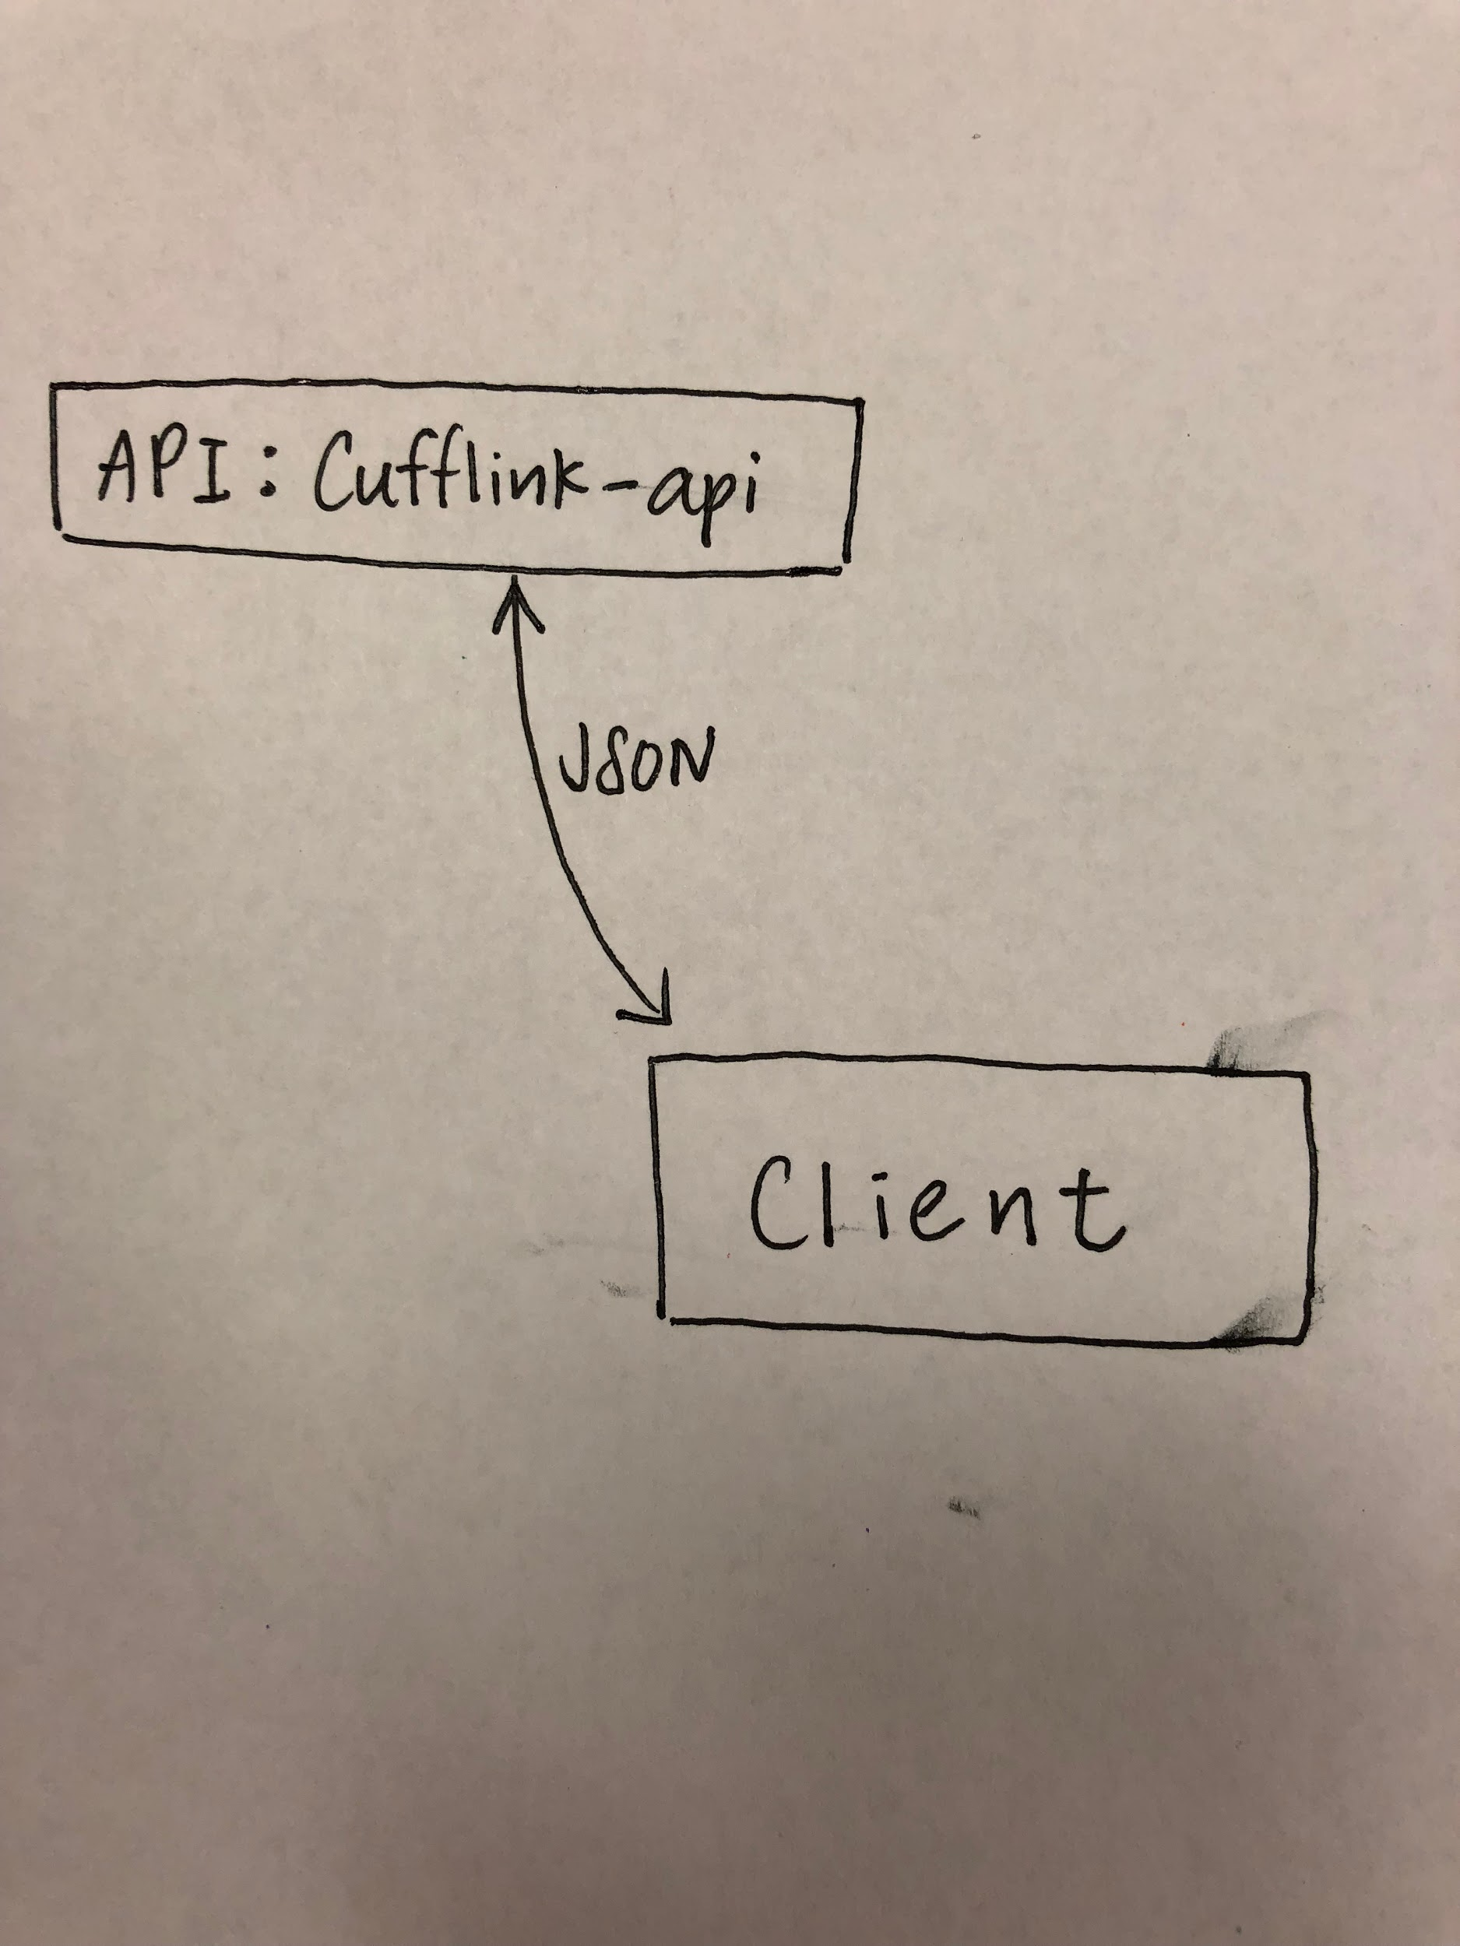

The data storage server stores its documents in the MongoDB database with a simple, single-file Node.js Express server. Authentication tokens are generated via JSON web token, which is a technology that helps with authentication for mobile applications. The communication mechanism is purely JSON, except for file uploads, which are directly uploaded as binary data using the URLSession API and UIImageJPEGRepresentation. Image file uploads are stored in MongoDB using the GridFS API. The Express server acts as a simple mediator between the data from the iOS application and the MongoDB data storage application.

API endpoints used include:

1. [POST] [http://hostIP/login](http://hostip/login) - this endpoint gives a token when an account is found with given user’s email and given user’s password

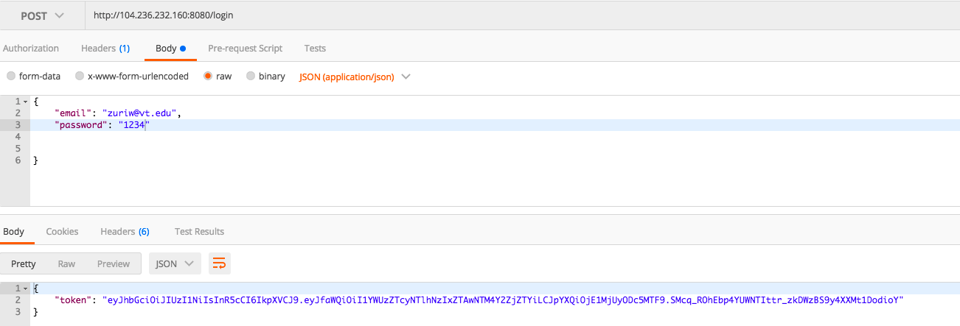

1. [POST] [http://hostIP/signup](http://hostip/signup) - this endpoint gives a response of success = true or success = false to indicate whether signup is completed with given email, password, first name, last name, address and phone number. This puts new user into the list of users.

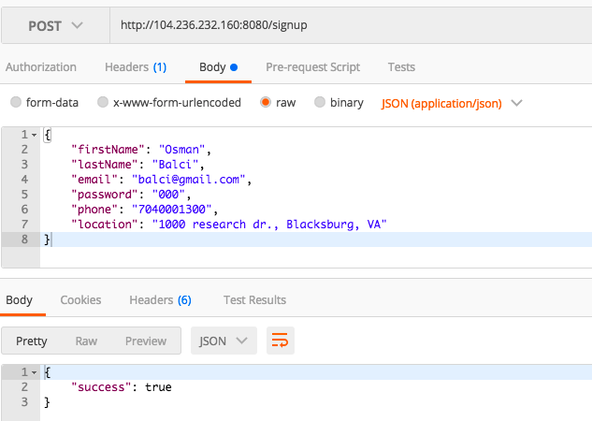

1. [GET / POST] http:// hostIP/items - This endpoint has all the items listed in an array with general information of each item when a get request is done. It also adds an item with item information as body when a post request is done. Token needs to be included in the header.

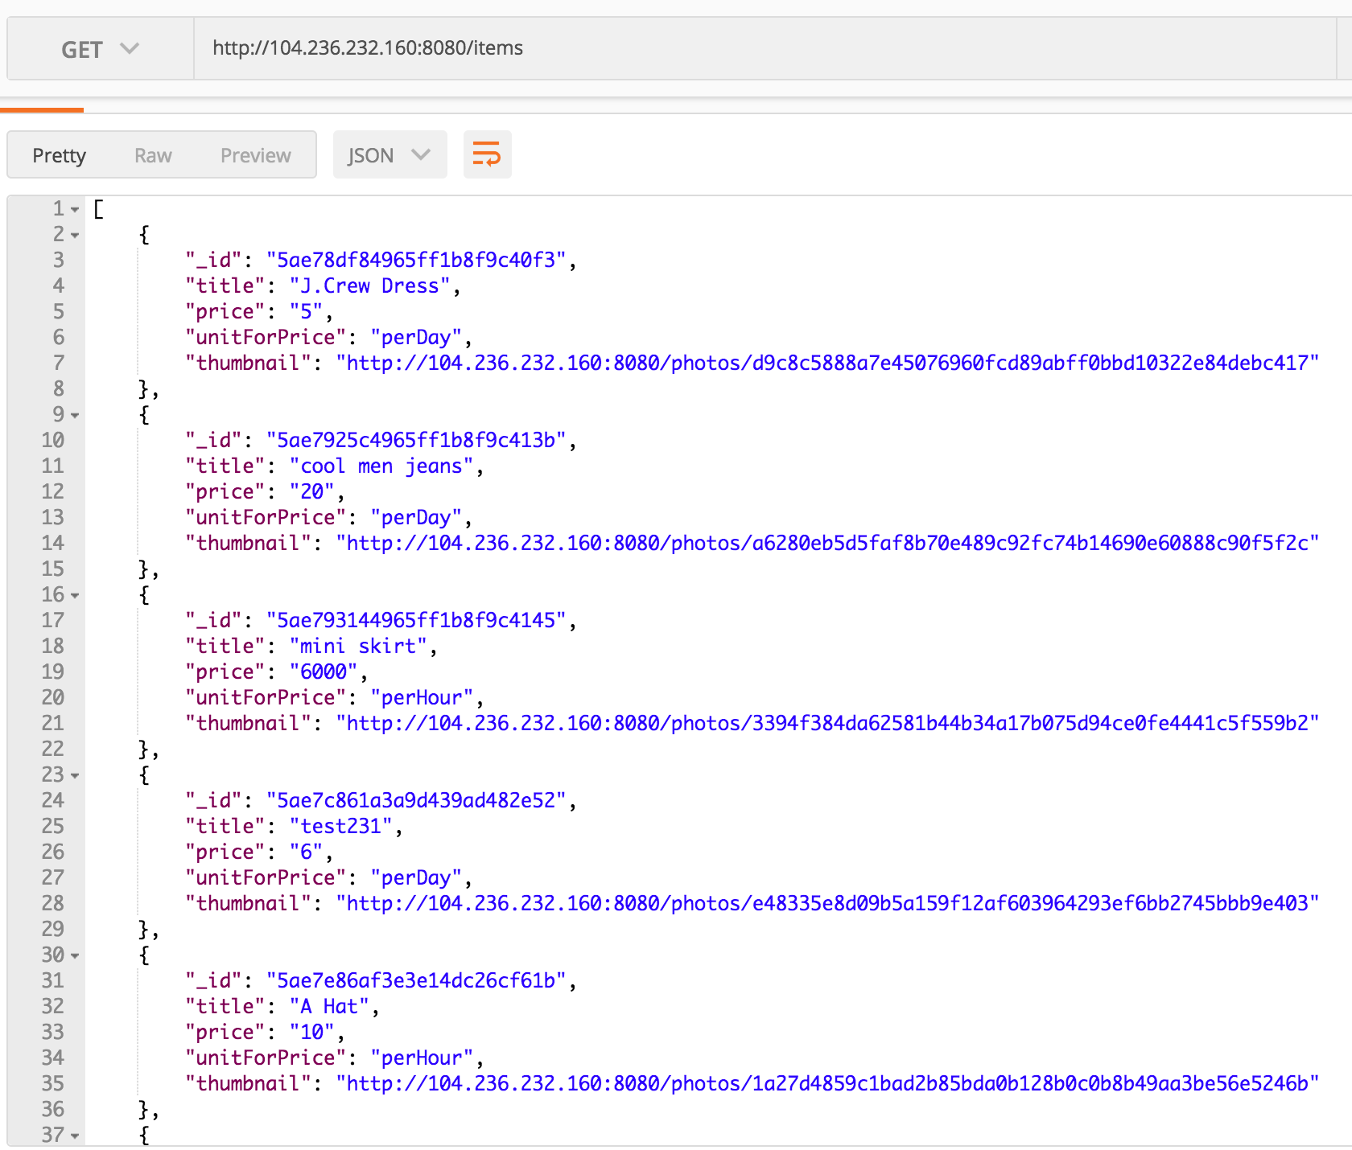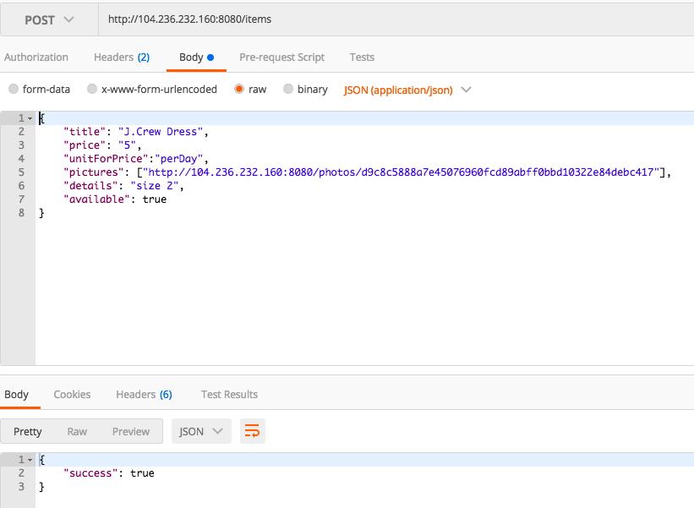

1. [GET / POST] http:// hostIP/items/itemID - this endpoint has the detailed information of the item associated with the provided ID. This endpoint can also be used to edit item information. Token needs to be included in the header.

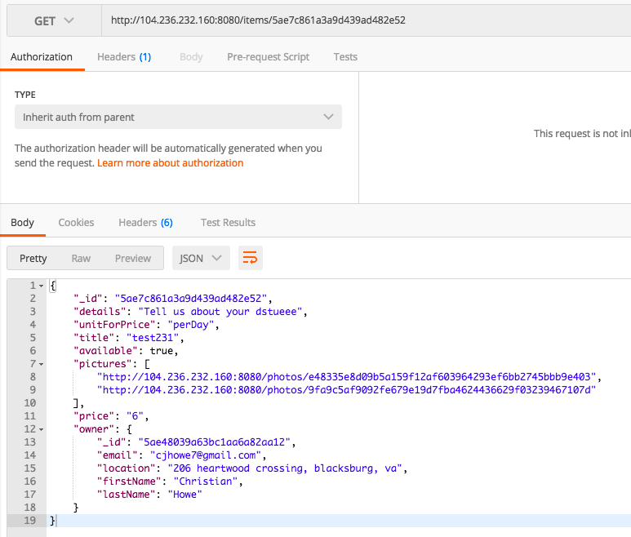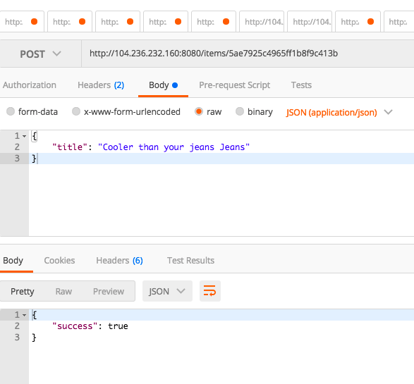

1. [GET][http://hostIP/users/userID](http://hostip/users/userID) - this endpoint has the detailed information of the user associated with the provided ID. Token needs to be included in the header.

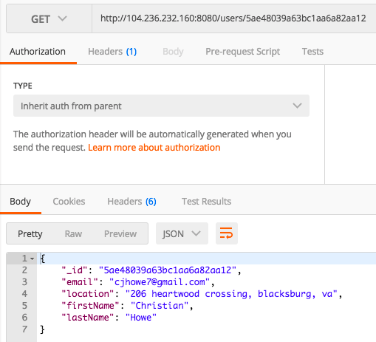

1. [GET][http://hostIP/users/userID/items](http://hostip/users/userID/items) - this endpoint has all the items of the user associated with the provided ID in an array with general information of each item. Token needs to be included in the header.

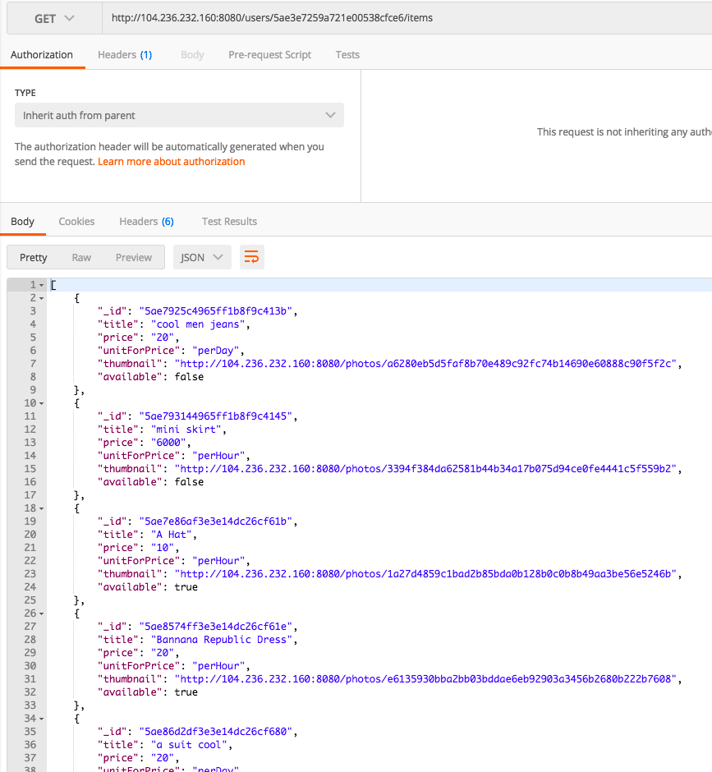

1. [GET / POST][http://hostIP/me](http://hostip/me) - this endpoint has all the detailed information of the current user logged in. This endpoint can also be used as a POST request to edit information of the current user. Token needs to be included in the header.

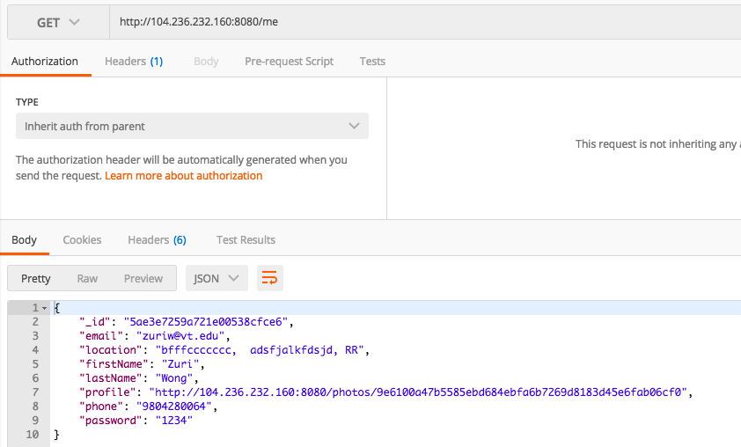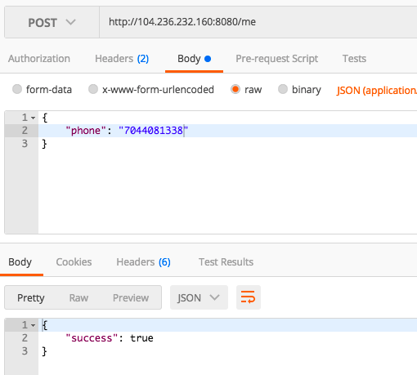

1. [GET] [http://hostIP/me/items](http://hostip/me/items) - this endpoint has all the items of the current user logged in. Token needs to be included in the header.

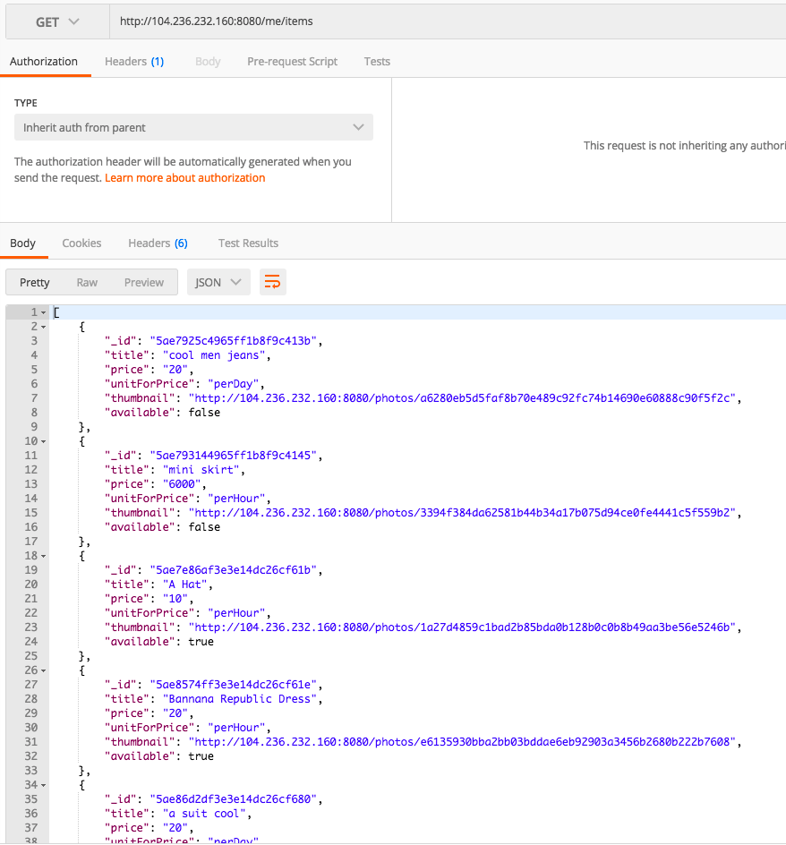

1. [POST] [http://hostIP/upload](http://hostip/upload) - this endpoint takes the selected photo in the body as binary form and upload the photo as an url, and gives the url in the response. Token needs to be included in the header.

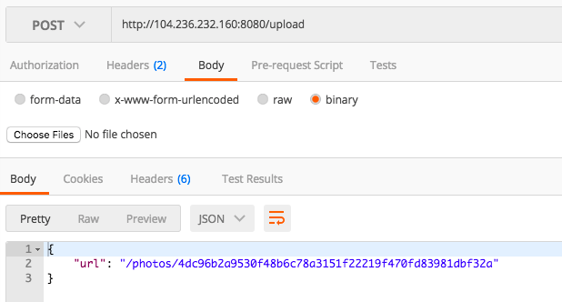

1. [POST][http://hostIP/changePassword](http://hostip/changePassword) - this endpoint takes the new password given in the body and change the old password with the new password of the current user logged in. Token needs to be included in the header.

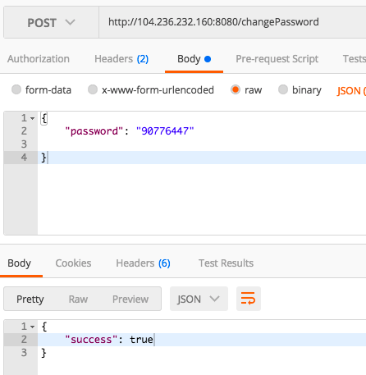

# DESIGN SPECIFICATION

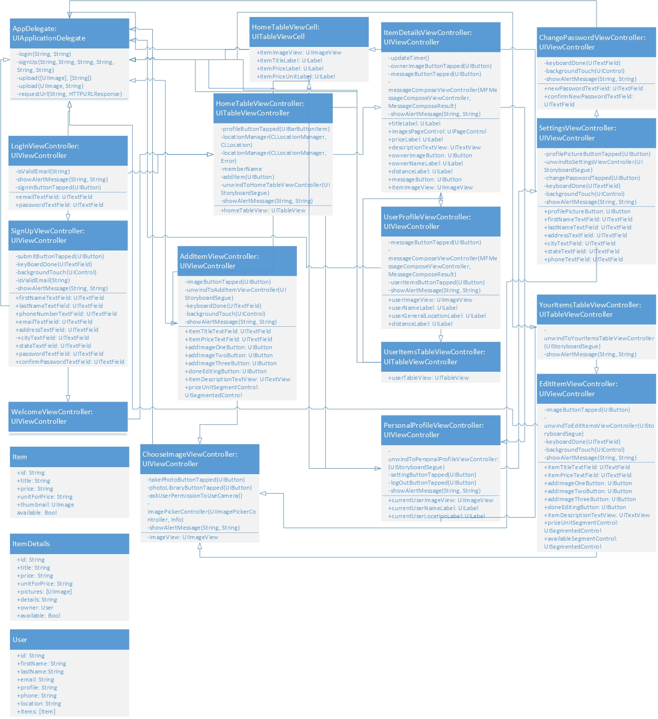

# DELIVERED SOFTWARE FUNCTIONALITY

This is our **LogIn View**, which is what user will see as soon as app icon is tapped. User can either login with an existing account, or create a new account by tapping “Sign Up”.

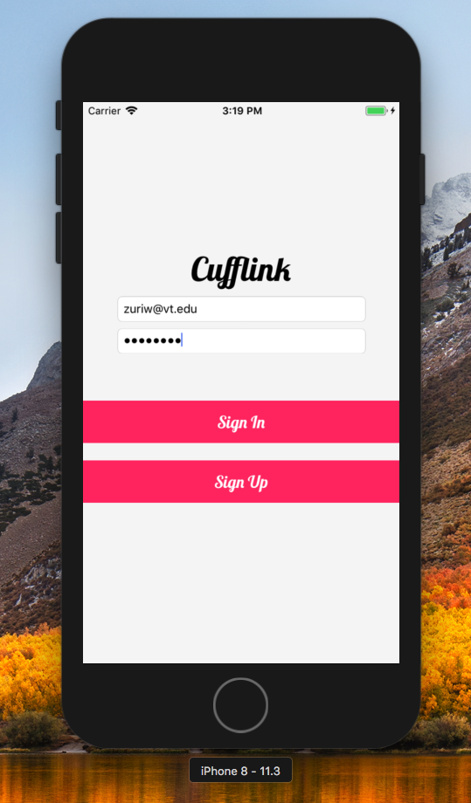

Verifications on log in is added as well, as seen below.

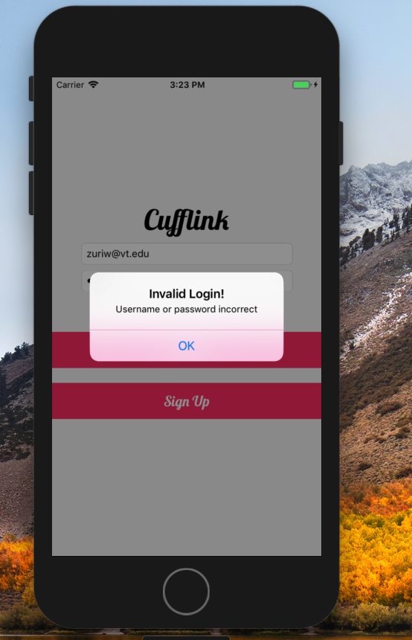

If user decides to sign in using an existing account, tapping “Sign In” will bring user to Home Table View which will be shown and explained later.

Endpoint used here: http://hostIP/login

If you choose to sign up, **SignUp View** will show.

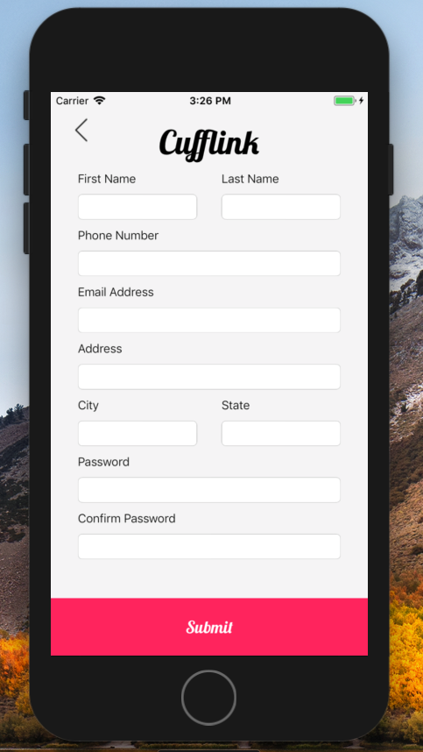

To make sure no make data is entered through the system, we have implemented textField delegate methods to prevent phone number from being more than 10 digits and State from being more than 2 characters.

To prevent keyboard from covering the view of the view, we shifted the view above the keyboard for all the textFields that will be covered when keyboard is shown. (This is used throughout the app)

As usual, we added “keyboard Done”, “background Touch” methods. (This is also used throughout the all)

Verifications on text fields being empty, email address not valid, location not valid, and matching passwords are added as well.

Shifting view upward as shown below.

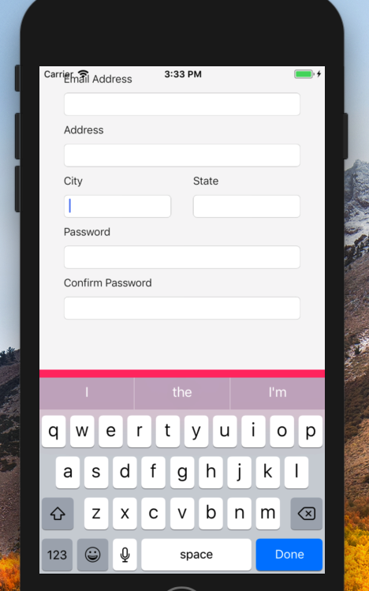

When user tap on the  button on the top left,

it will bring user back to the signIn View as seen on

the last page.

endpoint used here: http://hostIP/signup

Once all the required fields are filled out, and submit button at the bottom is tapped, a **Congratulation View** is shown.

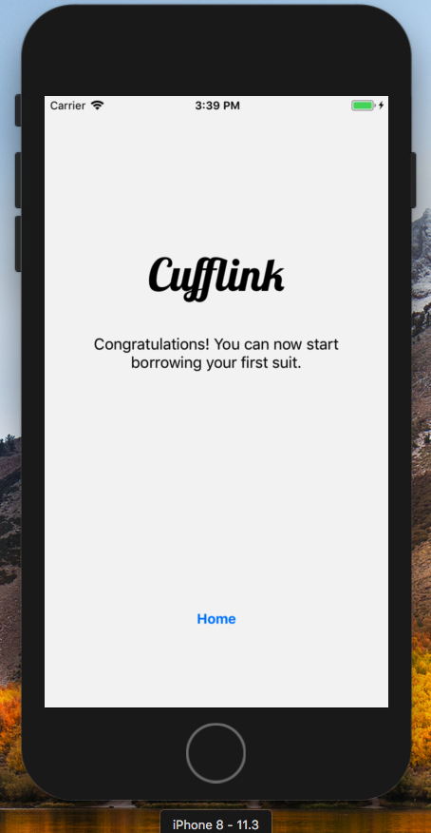

This view has only one button at the bottom. “Home” button brings user to the Home Table View of this app.

**Home Table View** shows all items available with a thumbnail, item title, and price with a unit (either per day or per hour).

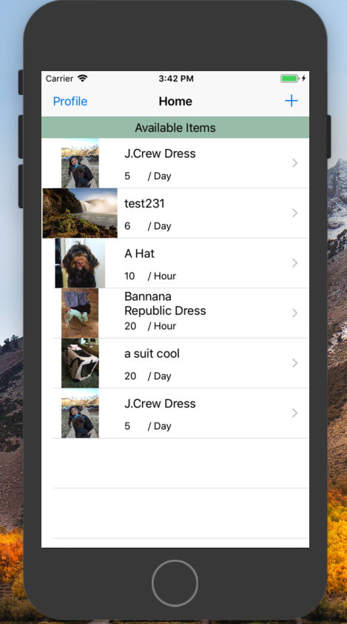

Each row represents each item. When row is tapped, **itemDetailsView** will be shown.

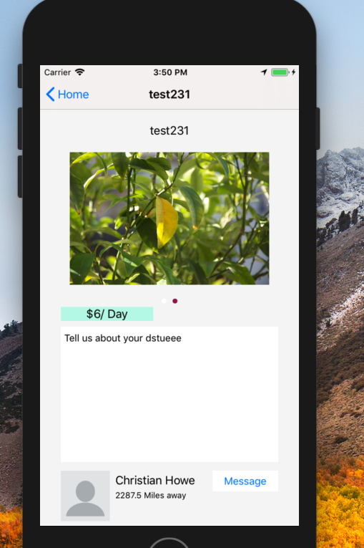

When user taps on “+” bar button on the top right, **addItemView** will be shown where user will enter information of the item and post it.

When user taps on “profile” bar button on the top left, **personalProfileView** will be shown, where user can see his/her information, or choose to edit information, or see all his/her items.

More details about each views will be explained thoroughly later in the Document.

endpoint used here: [http://hostIP/items](http://hostip/items), http://hostIP/items/itemID

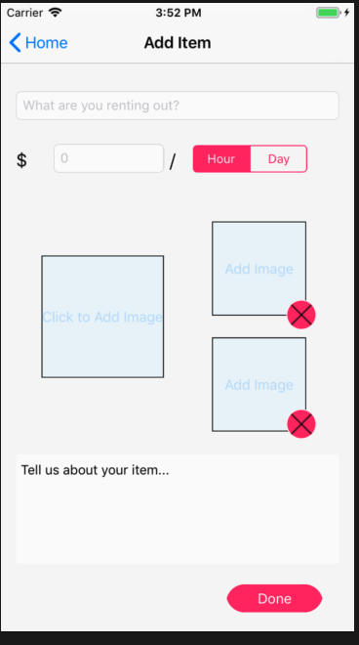

Here is our **AddItemView.** User will be able to put in a title (rough description of the item), the price, price unit (represented with segment control), three images, and a detailed description of the item.

Item must have a title, price (with unit), at least one image, and a description. Verification is added to prevent misinformation entered.

User can tap on any of the imageView to bring up **ChooseImageView** to take a picture with the iphone, or select a picture from Photo Library.

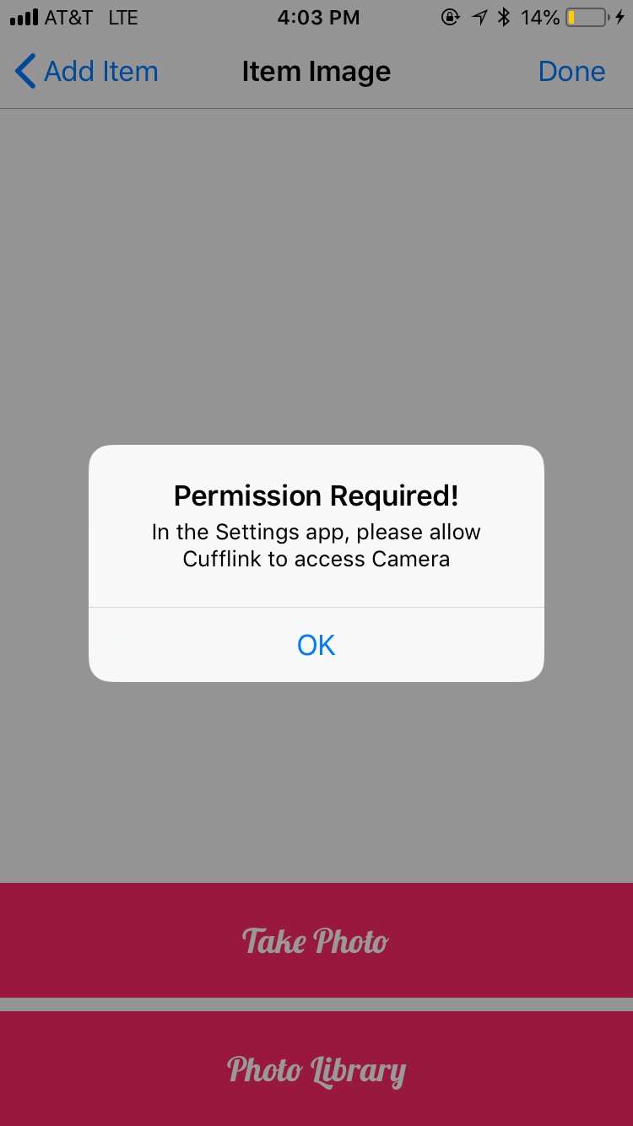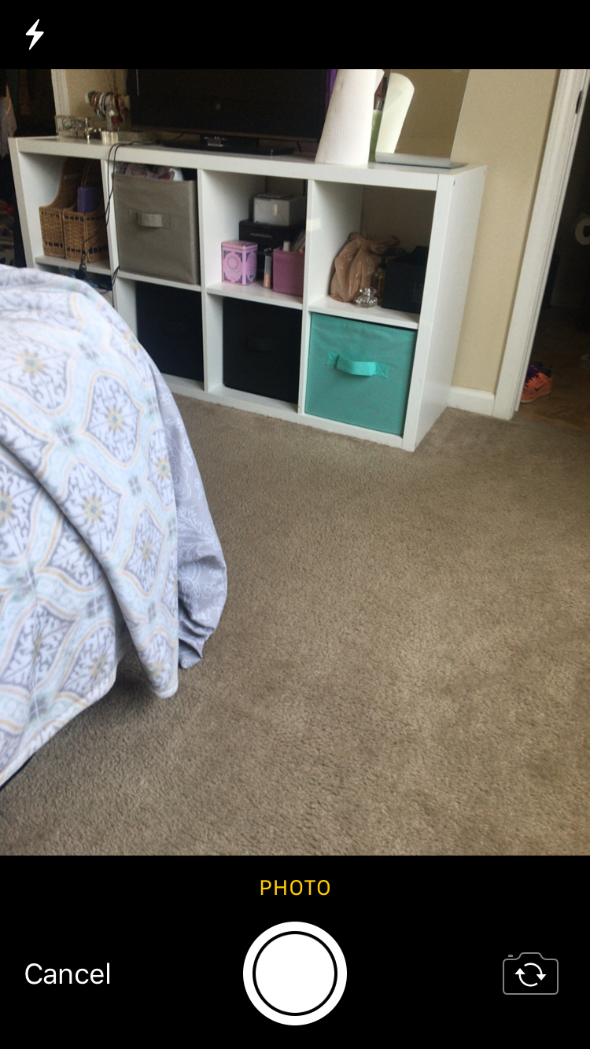Permission is asked when user uses the camera.

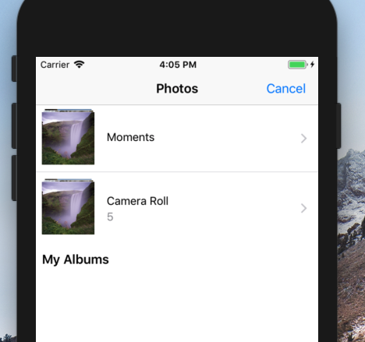

Photo Library is shown when “Photo Library” is tapped.

Tapping on the 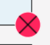 button deletes the image chosen.

endpoint used here: [http://hostIP/items](https://hostip/items), [http://hostIP/upload](http://hostip/upload)

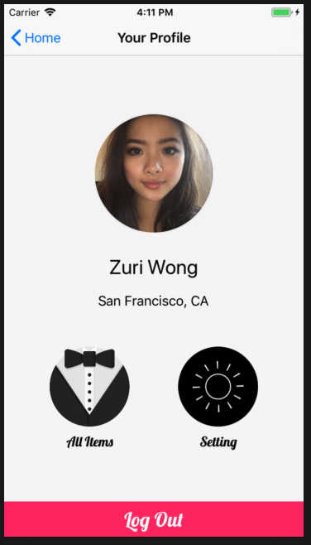Here is our **PersonalProfileView**.

PersonalProfileView shows the currently logged in user’s profile. It has a imageView which becomes circular at runtime.

This profile view shows user’s first and last name, and his/her general location by using reverse geolocation. It tracks user’s current location, and by using its coordinate to reverse geo-locate the user’s general location.

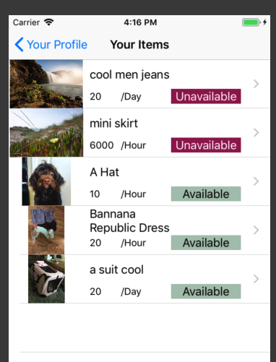Tapping “All Items” brings up **YourItemTableView**, which has all the items current user posted.

Besides all the mentioned details of the items in HomeTableView, this also includes ones that are unavailable.

More details about **YourItemTableView** in the next page.

Tapping on “Setting” will bring up **SettingsView.**

More about SettingsView later in the document.

Tapping on “Log Out” will user back to **LogInView**.

endpoint used here: http://hostIP/me/items

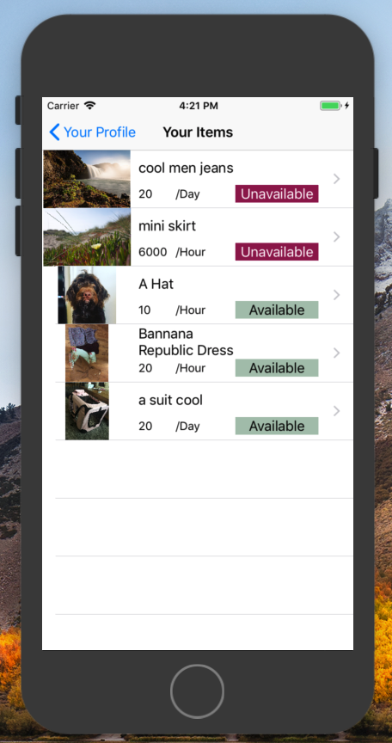Here is our **YourItemTableView**.

It is structured similarly to HomeTableView. It shows all items of the current user, and its availability in color coded background for user-friendly purpose.

By clicking on item (row), it brings up **editItemView**, which is structured similarly to **addItemView**.

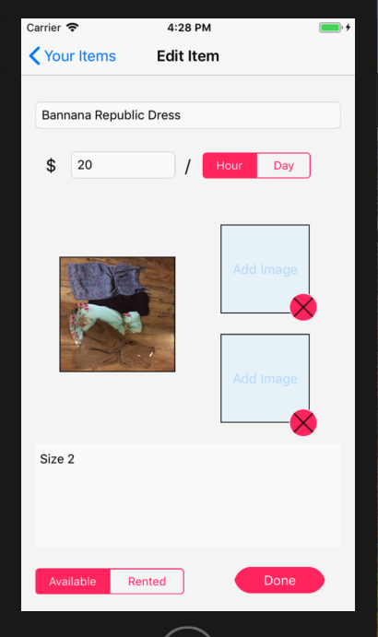

Besides editing the title, price, pictures, and description. **EditItemView** allows user to change item availability from “available” to “rented” if an item is rented. Tapping “Done” will unwind back to **YourItemTableView**, and YourItemTableView will be reloaded.

endpoint used here: [http://hostIP/](http://hostip/userID/items/itemID)me/items, http://hostIP/upload

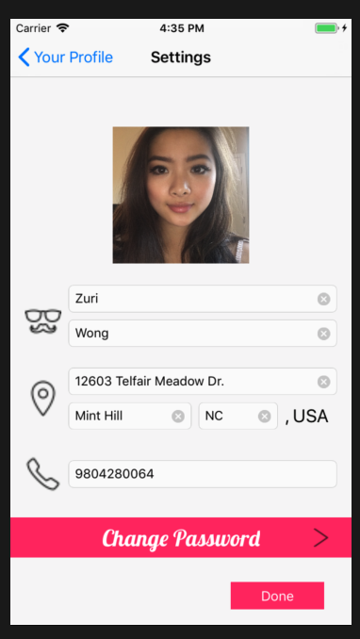Tapping “Setting” on PersonalProfileView will bring up **SettingsView** as mentioned.

Here user can change his/her profile picture by tapping on the imageButton, which will brings up **ChooseImageView** as shown before**.**

User can have the ability to change his/her information and will be saved when “Done” is tapped and unwind back to **PersonalProfileView**.

When user choose to change password, user can tap on “Change Password”, which will brings up **ChangePasswordView**.

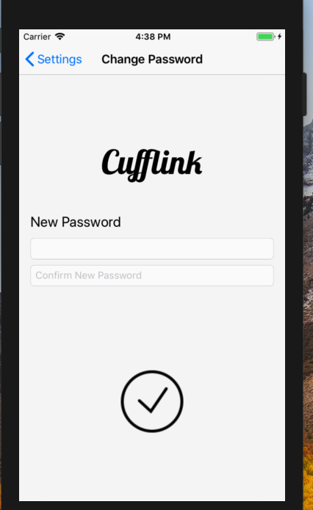

Verification is added on matching new password with confirm password.

When user is done, simply tap on the circular check button .

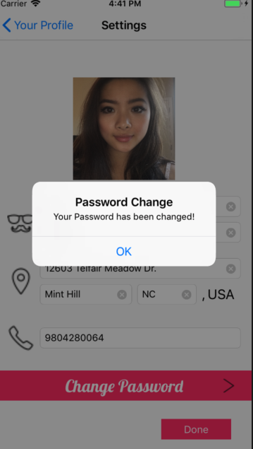

A confirmation of password change (message box) will be shown when it is done

endpoint used here: [http://hostIP/changePassword](http://hostip/changePassword), [http://hostIP/me](http://hostip/me)

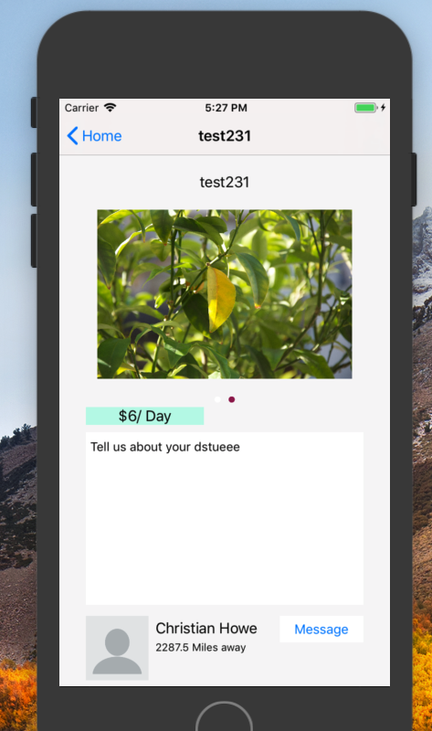Remember tapping on a row in HomeTableView will bring up **ItemDetailsView**? Here it is.

ItemDetailsView includes a image slideshow that will alternate between the number of images uploaded for the selected item in an iteration of 2 secs. It also shows all the item details like the title, price, and description. At the bottom it displays the owner’s name and the distance between current user’s current location and the location of the owner from the his/her profile.

When user tap on owner’s profile icon at the bottom, it brings up **UserProfileView** of the owner.

UserProfileView will shown next page.

User can also tap on message button at the bottom next to owner’s name to display user’s iphone message screen as shown below with a preset message.

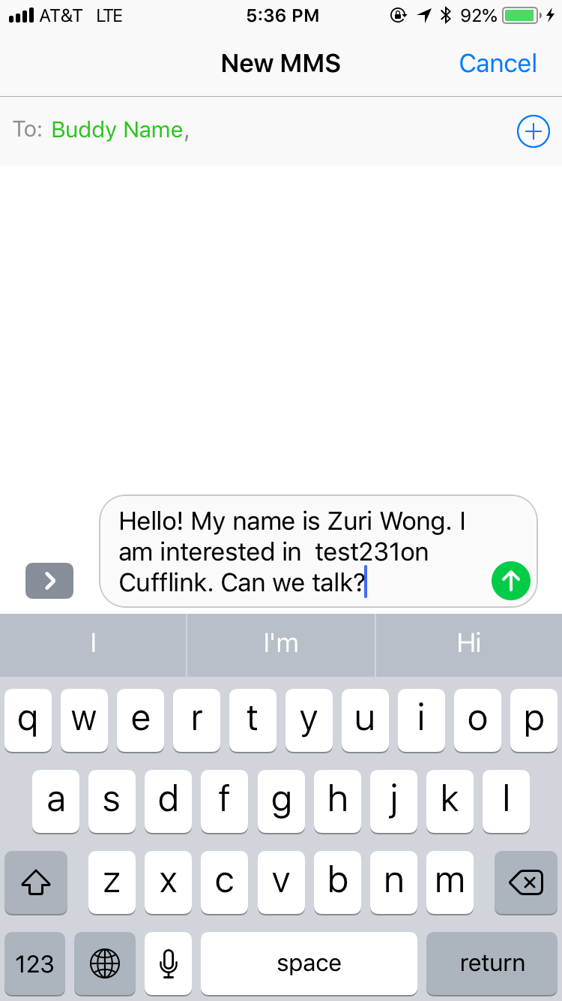

endpoint used here: [http://hostIP/items/itemID](http://hostip/items/itemID)

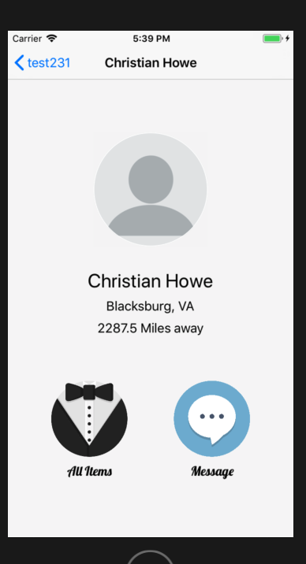Here is our **UserProfileView**.

This view displays the selected (owner) user profile. Profile includes user’s profile picture in the circular imageView structured similarly to **personalProfileView**.

It also includes user’s general location, and distance between this user and currents user’s location using geo-location similar to personalProfileView.

Tapping on “Message” button will bring up user’s iphone message scene with a different pre-set message as before, similar to image shown below.

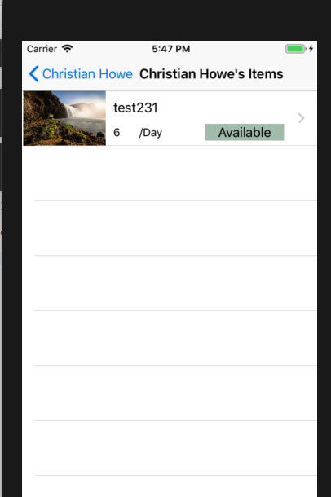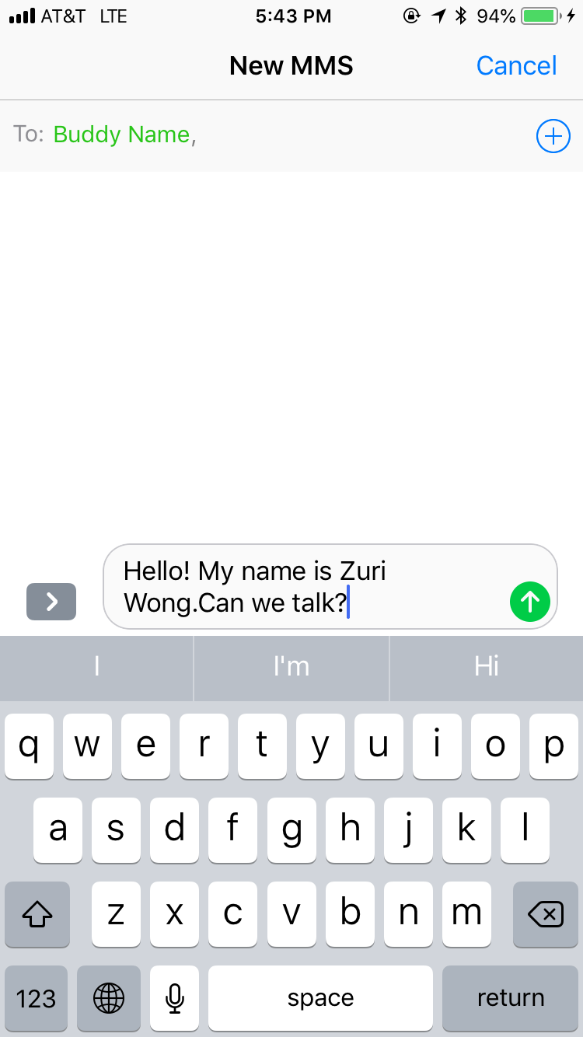Tapping on “All Items” brings up **UserItemTableView** which is structured similarly to **HomeTableView** and **MyItemTableView**.

UserItemTableView shows all items of the user.

Endpoint used here: [http://hostIP/users/userID](http://hostip/users/userID), [http://hostIP/users/items](http://hostip/users/items), [https://hostIP/items/itemID](https://hostip/items/itemID)

# STEP-BY-STEP INSTRUCTIONS FOR DEVELOPING NEW FEATURES

## Use Activity Indicator to load scenes

Activity Indicator is a waiting animation, good to be added for user-friendly design in application to inform users that something is happening behind the scene, please wait.

**Step 1.**

We are going to create an UIActivityIndicator. Here I’m going to use the UIActivityIndicatorViewStyle.gray as my indicator style.



**Step 2.**

Here we are going to customize the activityIndicator so that it is centered when shown.

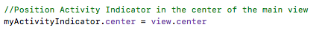

**Step 3.**

To use the activityIndicator, we are going to have it start animating. Code as shown below.

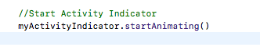

and don’t forget to add the UIActivityIndicator to view.

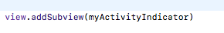

**Step 4.**

Now activityIndicator is going to show on the center of the screen.

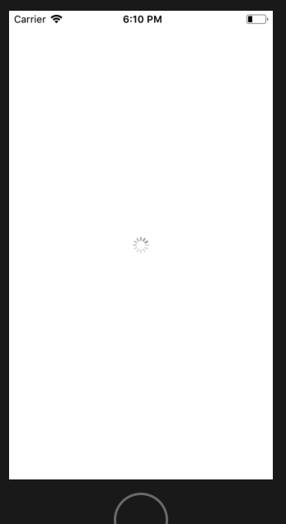

To make it stop animating, we are going to use the following code.

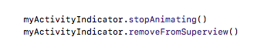

## Select Photos from User’s Phone Photo Library

**Step 1.**

First we are going to open a Single View project in Xcode. Then we are going to go to Main.storyboard, and drag a UIImageView onto the view controller. Set UIImageView dimension as (0,0,375,495) view as iphone 8.

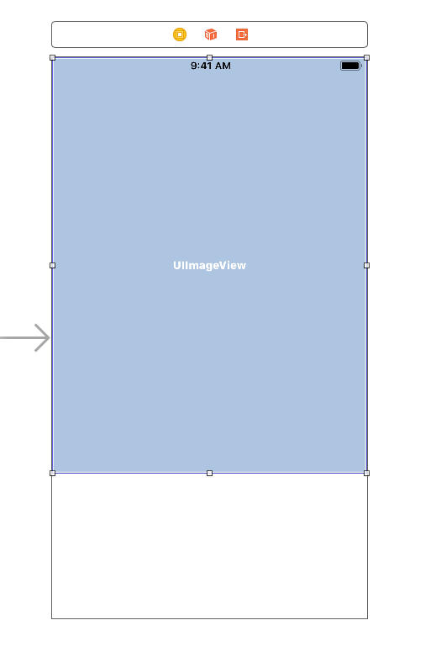

Then we are going to set the constraints as below.

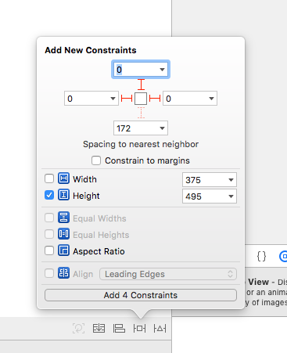

**Step 2.**

Now create a UIButton (141, 557, 92, 30)onto the view controller, assign it a title : “Photo Library”.

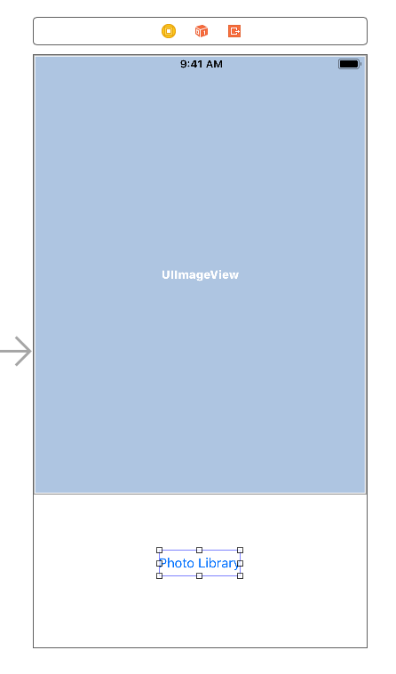

Now add constraints as such.

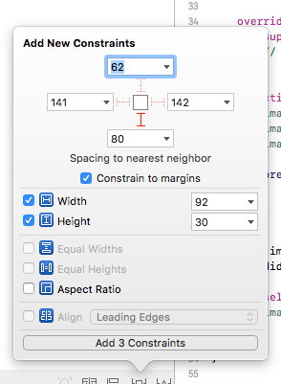

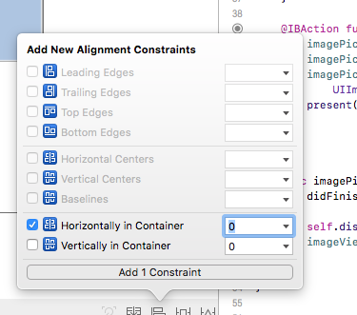

**Step 3.**

Open assistant Editor. Control drag from UIImageView to viewController.swift to create outlet.

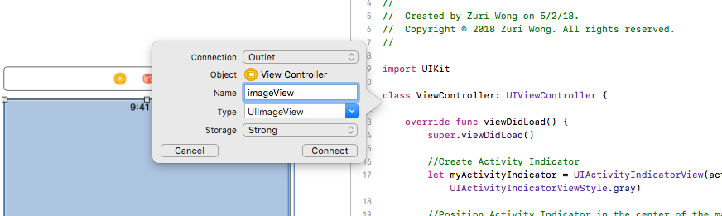

**Step 4.**

Add UIImagePickerControllerDelegate and UINavigationContollerDelegate into viewController.swift.

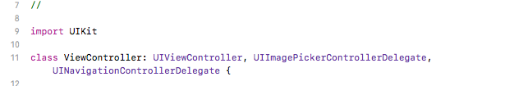

**Step 5.**

Add an instance of UIImagePickerController into viewController.swift at the top as a variable.

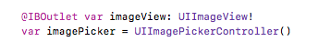

**Step 6.**

Create an action outlet for photoLibraryButton, type = UIButton.

Call it “photoLibraryButtonTapped”, click connect.

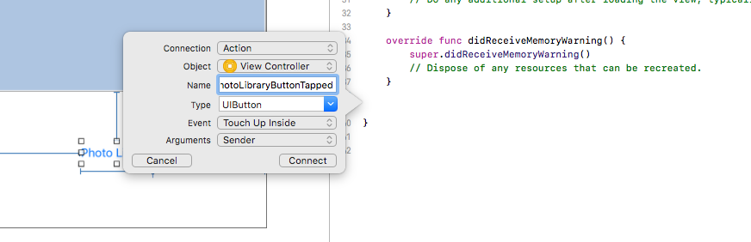

**Step 7.**

Inside photoLibraryButtonTapped, use code following.

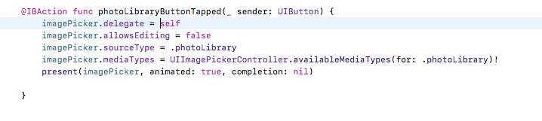

**Step 8.**

Implement delegate method.

Since we want the image to show on UIImageView, use code following.

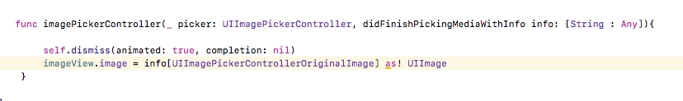

**Step 9.**

Save and run.

Click on Photo Library Button shows this. Click on an Image.

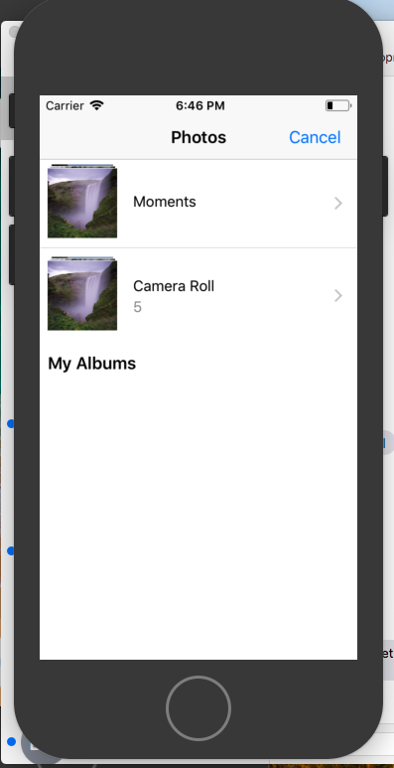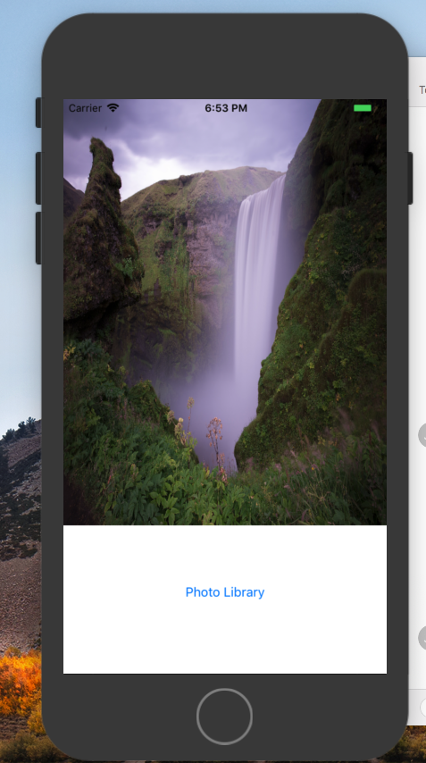

## Opens Messaging app and pulls phone number

**Step 1.**

First we are to create a Single View project in Xcode. We then want to import the MessageUI.framework in order to be able to send messages.

**Step 2.**

Go to Main.Storyboard and drag a UIButton onto the view controller. With iPhone 8 set as “view as”, set the UIButton’s dimensions to (152, 155, 71, 30) and set the title to “Send SMS”. Then apply the following constraints and set the button to be horizontally in container.

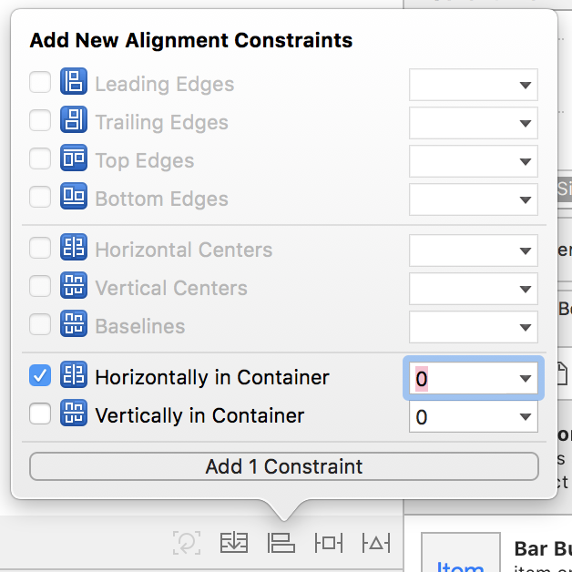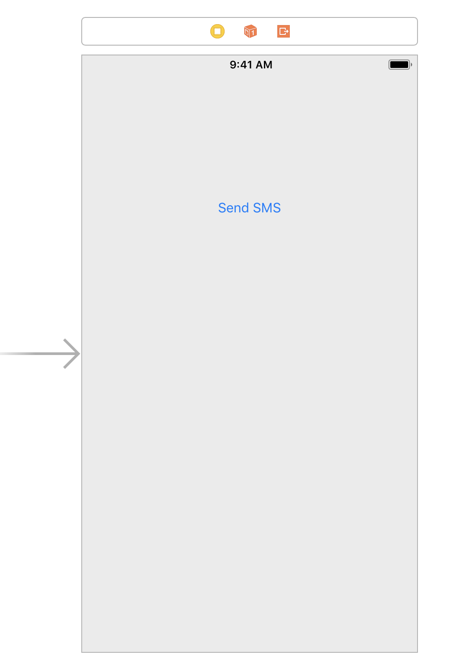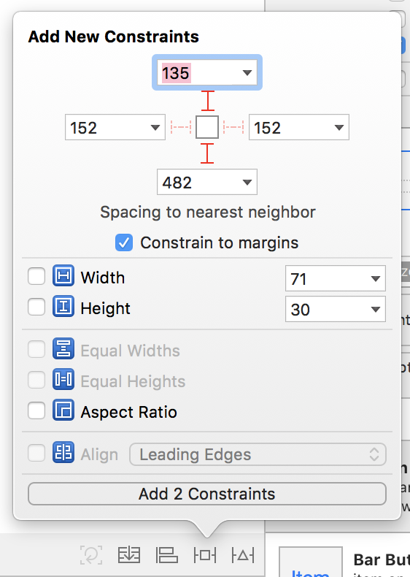

**Step 3.**

Open the Assistant Editor. Control drag from the newly created UIButton to ViewController.swift to create an action for when the button is tapped.

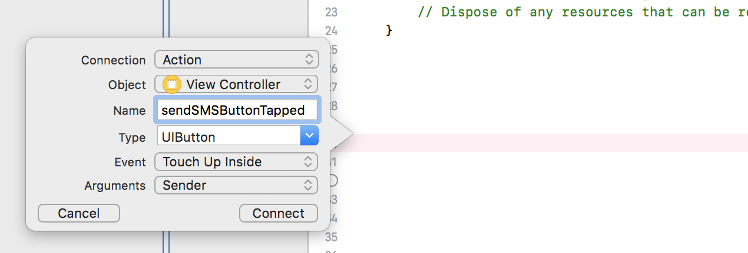

**Step 4.**

Add MFMessageComposeViewControllerDelegate into ViewController.swift and import MessageUI.

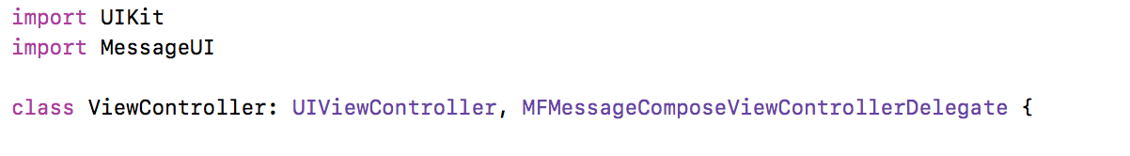

**Step 5.**

Finish your newly created action with the following code.

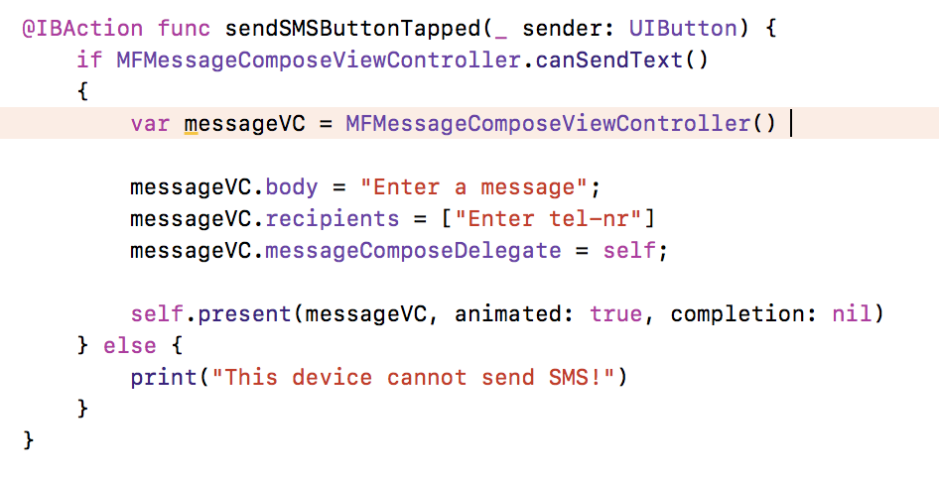

**Step 6.**

Create messageComposeViewController function.



**Step 7.**

Save and run. Note that the simulator is unable to send SMS so it will always print “This device cannot send SMS!”, however this will not be the case if tested on an iPhone.

# CONCLUSIONS

The team project was a beneficial learning experience for all of our team members. The team project was an excellent example of the software life cycle and its multiple, intricate steps. We were able to show off all of the new skills we learned from the course, while also implementing new features that we have never seen before. We learned about what our requirements specification should be and how to develop our architecture and design specification. We were able to implement a software application as a solution to our project specification. Overall, the team project was a great way to gain hands on and team learning experience when developing for iOS.

# SUBMISSION INSTRUCTIONS

Please carefully follow the instructions below in submitting your project:

1. Place this project report file Team N Semester Project Report.docx and Xcode project folder in a folder named TeamN-iOSProject and compress it, where N is your team number.
2. Unzip the compressed file on another computer and make sure that the zip file is properly created. Only zip files are accepted.
3. Upload your zip file to your account in [Google Drive](https://www.google.com/drive/), right click the uploaded file and select **Share** from the pop-up menu, enter [balci@vt.edu](mailto:balci@vt.edu), add a note as CS3714 Team N Project Submission, and click Send before 8:00 a.m. on May 4 Friday**.** **Late submissions are not allowed.**
4. If your project iOS app is a multi-user app or an app that requires demonstration to evaluate its functionality, then get an appointment with Dr. Balci **before the due date** and go to his office to give a hands-on demo so that your app can be graded properly.

# PERCENTAGES OF CONTRIBUTION

We hereby certify that the list of contributions and the corresponding percentages of contribution specified below truly reflect the actual contributions of the team members.

|  |  |  |
| --- | --- | --- |
| *Student Name & List of Contributions* | *% Contributed* | *Signature* |
| Zuri Wong’s Contributions:   1. created all UI designs 2. wrote code behind Login, signup, home table view, personal profile view, settings, your item table view, change password, choose image, item details, user profile, user items, user item details, congratulation view controllers 3. created all power points for presentation 4. created documentations for design architecture, application functionalities, and two of three step by step tutorials for new features | 50% | Zuri Wong |
| Joe Chu’s Contributions:   1. helped create powerpoints for presentations 2. created the UML Diagram 3. created documentation for design specifications, opens messaging app and pulls phone number step by step tutorial, Conclusions, and Appendix A: Meeting Minutes | 10% | Joe Chu |
| Christian Howe’s Contributions:   1. wrote code for personal profile items, editing of personal profile items, AppDelegate method for requestUrl 2. wrote the backend JSON API 3. helped create powerpoints and UML 4. created initial item detail user interface | 40% | Christian Howe |
| Sum of Percentages: | 100% |  |

The **Virginia Tech Honor Code** is fully in effect for the above declaration. The percentage of contribution must be justified by the list of contributions specified in detail.

If you disagree with your team members, you and the other team members must separately email Dr. Balci and indicate what each member thinks the fair percentages of contribution are for all team members.

# CALCULATION OF GRADES BASED ON PERCENTAGES OF CONTRIBUTION

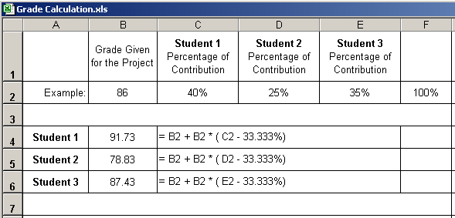

**Additional percentage of contribution cannot exceed 10%.**

**If a situation arises where a student is doing more than 10% extra work, Dr. Balci must be informed immediately.**

# TEAM PROJECT REQUIREMENTS

1. Each team member is expected to contribute equally.
2. You shall submit percentages of contribution together with a list of each student’s individual contributions with signatures of all team members. In case of disagreement, you shall submit it separately with your rationale. (Write your name as representing your signature.)
3. Grades shall be determined based on the percentages of contribution.
4. If you contribute more than your equal share, then your grade shall be increased based on the extra percentage of contribution, which cannot be more than 10%.
5. If you contribute less than your equal share, then your grade shall be decreased accordingly.
6. The extra percentage of contribution shall not be more than 10%. Dr. Balci shall be notified immediately if a situation arises where a student needs to contribute more than 10% extra.
7. A team member who does not cooperate with other team members for conducting the project with equal contribution shall be penalized. Doing more work than agreed upon by the team and claiming extra contribution shall not be acceptable. Cooperation is essential!

# GRADING SHEET

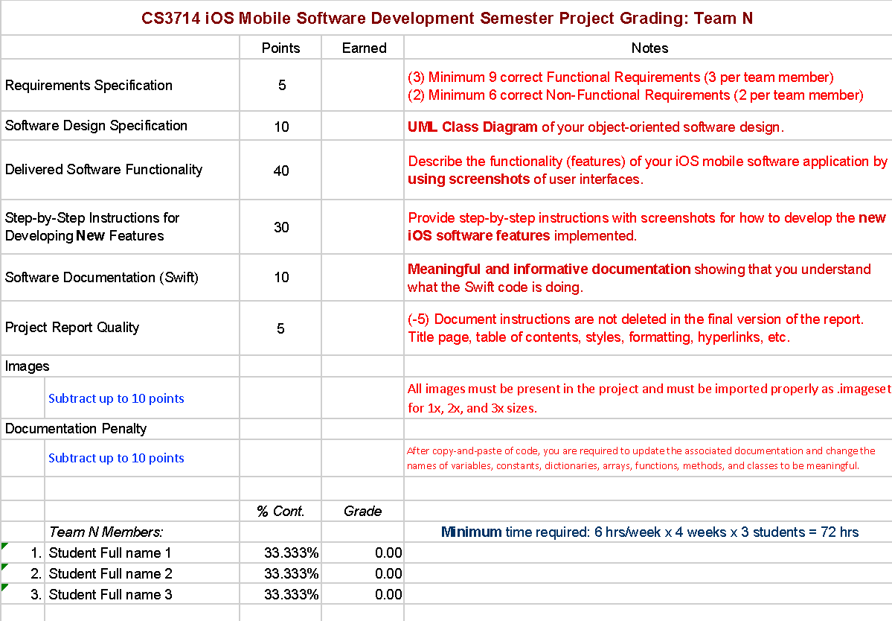

**REFERENCES**

Apple, Inc. (2017), “iOS Developer Library,” <https://developer.apple.com/library/ios/navigation/index.html>

Balci, O. (2016), “CS3714 iOS Mobile Software Development Course Website,” <https://manta.cs.vt.edu/cs3714>

Stack Over Flow(2017), “Questions,”

<https://stackoverflow.com>

**APPENDIX A: MEETING MINUTES**

**Meeting Number 1**

|  |  |
| --- | --- |
| *Date & Duration:* | March 19, 2018 - 2:00 - 4:00 |
| *Location:* | Surge |
| *Members Present:* | Zuri Wong, Christian Howe, Joe Chu |
| *Members Absent:* | NA |
| *Discussions:* | Determining our problem specification and our requirements specifications. |
| *Decisions Made:* | Determined learned and new iOS features to be used in Cufflink. |
| *Work Assignments:* | Finish our functional and nonfunctional requirements. |
| *Minutes Prepared By:* | 30 minutes |

**Meeting Number 2**

|  |  |
| --- | --- |
| *Date & Duration:* | April 2, 2018 - 2:00 - 5:00 |
| *Location:* | Surge |
| *Members Present:* | Zuri Wong, Christian Howe, Joe Chu |
| *Members Absent:* | NA |
| *Discussions:* | Finalizing our problem specification and our requirements specification. |
| *Decisions Made:* | Finished our requirements specification. |
| *Work Assignments:* | Finish presentation for April 5th. |
| *Minutes Prepared By:* | 30 minutes |

**Meeting Number 3**

|  |  |
| --- | --- |
| *Date & Duration:* | April 9, 2018 - 2:00 - 6:30 |
| *Location:* | Surge |
| *Members Present:* | Zuri Wong, Christian Howe, Joe Chu |
| *Members Absent:* | NA |
| *Discussions:* | Determining our architecture specification and design specification. |
| *Decisions Made:* | Determined how we wanted the UI and storyboard layouted. Worked on presentation for class. |
| *Work Assignments:* | Finish storyboard layout. Finish presentation for April 12th. |
| *Minutes Prepared By:* | 30 minutes |

**Meeting Number 4**

|  |  |
| --- | --- |
| *Date & Duration:* | April 16, 2018 - 2:00 - 6:00 |
| *Location:* | Computer Science Lounge |
| *Members Present:* | Zuri Wong, Christian Howe, Joe Chu |
| *Members Absent:* | NA |
| *Discussions:* | Discussing our software components and programming |
| *Decisions Made:* | Worked on View Controllers and presentation for class. |
| *Work Assignments:* | Finish View Controllers and presentation for April 19th |
| *Minutes Prepared By:* | 30 minutes |

**Meeting Number 5**

|  |  |
| --- | --- |
| *Date & Duration:* | April 20, 2018 - 10:30 - 1:30 |
| *Location:* | Starbucks on South Main |
| *Members Present:* | Zuri Wong, Christian Howe, Joe Chu |
| *Members Absent:* | NA |
| *Discussions:* | View Controller Design and User login |
| *Decisions Made:* | How we want to implement user login. |
| *Work Assignments:* | Finish View Controllers |
| *Minutes Prepared By:* | 30 minutes |

**Meeting Number 6**

|  |  |
| --- | --- |
| *Date & Duration:* | April 27, 2018 - 12:00 - 4:00 |
| *Location:* | Starbucks on South Main |
| *Members Present:* | Zuri Wong, Christian Howe, Joe Chu |
| *Members Absent:* | NA |
| *Discussions:* | Working on View Controllers |
| *Decisions Made:* | Working on View Controllers |
| *Work Assignments:* | Finish View Controllers |
| *Minutes Prepared By:* | 30 minutes |

**Meeting Number 7**

|  |  |
| --- | --- |
| *Date & Duration:* | April 30, 2018 - 3:30 - 6:30 |
| *Location:* | Starbucks on South Main |
| *Members Present:* | Zuri Wong, Christian Howe |
| *Members Absent:* | Joe Chu |
| *Discussions:* | Debugging |
| *Decisions Made:* | Debugging |
| *Work Assignments:* | Finish View Controllers |
| *Minutes Prepared By:* | 30 minutes |